ITMO 440/540 - Data Networks

The Real-Time Media Project - Assignment 1A

Assigned: 09/17/2015 Due: 09/24/2015

Name: ___Hong Zhang_____________________________________________

The host computer that I am using for my testing is a desktop and the operating system is 64-bit Windows 8.1, build 9600. Its CPU is Intel(R) Core(TM) i3-4150 CPU @ 3.50GHz 3.50GHz and Memory usage is 8.00 GB.
The network which I am testing is located in my house and it gets Internet access from the company, WOW! I use a wireless Local Area Network in my house. Hence, this computer which I am using, my husband’s laptop, the printer and two Apple iPad all connect with a Wi-Fi Router. The topology of my house’s network is a star one. The IP Address of the computer is 192.168.1.6 and the IP address of my default gateway is 192.168.1.1.
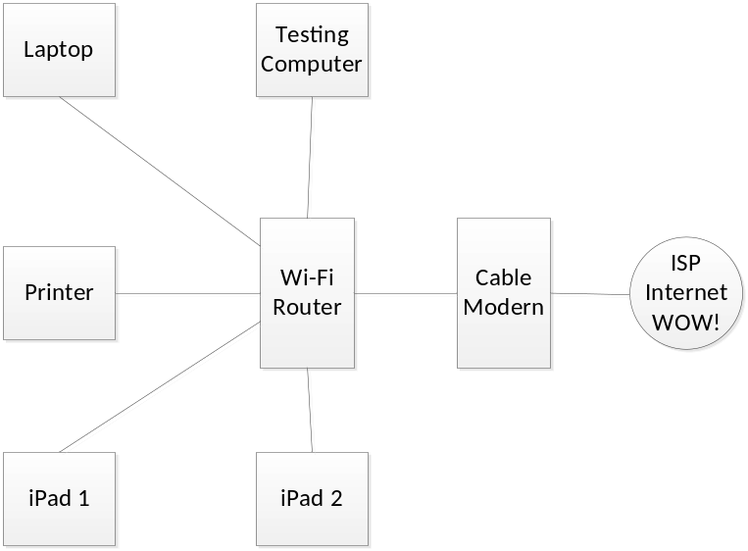
Figure 1. Test Bed Architecture
Before every testing, I always measure the upload and download speeds for the testing computer.
 | Download Speed | Upload Speed
Real-Time Media Project | 32.68 Mbps | 5.41 Mbps
Table 1. Test Bed Speeds
When I did this Real-Time Media Project, I turned off all the applications on this host computer. The protocols showed in this trace are ARP, HTTP, HTTP/XML, ICMP, LLMNR, MDNS, NBNS, TCP and UDP.
In layer 2, Ethernet II, there were 10 conversations. I find the address, HonHaiPr_13:d1:45 which is the testing computer wireless. It talked with different addresses, such as Netgear_25:06:6c that is the router, Apple_f0:cd:ae that is the iPad, Apple_05:a3:9f that is another iPad. At the same time, different address communicated with each other.
In IPv4, there were 8 conversations. The most conversations happened between this testing computer and other devices. The most exchange was this host and the IP address 192. 168.1.7. They exchanged 22 packets, 8,224 bytes. The rest addresses were 192.168.1.1 which is the default gateway, 192.168.1.2, 192.168.1.3, 192.168.1.5, 192.168.1.255, 224.0.0.251 which is Multicast DNS (mDNS) address and 224.0.0.252 which is Link-local Multicast Name Resolution. They had similar address type. This proved they were all the devices in our house’s wireless network. As we saw in the Figure 1, Test Bed Architecture, there are five devices sharing the network.
In TCP, there are 2 conversations. They are all happened in this host and the IP address 192. 168.1.7. They exchanged 19 packets. The testing computer sent 9 packets, 598 bytes to 192. 168.1.7. 192. 168.1.7 sent 10 packets, 7416 bytes to the host.
In UDP, there were 15 conversations. Most of them were the host talked with other devices. The most exchange was this host and the IP address 192. 168.1.255. the testing computer sent 6 packets, 552 bytes to 192. 168.1.255.
In this trace, I used 30.314 seconds and captured 64 packets, total 11,177 bytes. The average packet size is 175 bytes. The average bit rate is 368.711 bytes/second. During this test, the most exchange happed is the host talked with 192. 168.1.7. The bytes which they exchanged were 71.7% of total amount bytes during this capture. Another interesting thing was the host kept communicating with other devices in this wireless network. Because there are five computer devices in this network, even the host have not done anything, the conversation still have. These devices communicate with each other and the environment is very noisy.

